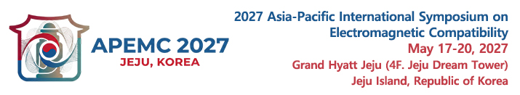
https://apemc2027.org/

The 2027 Asia-Pacific International Symposium on Electromagnetic Compatibility (APEMC 2027) will be held at the Grand Hyatt Jeju in Jeju Island, Republic of Korea, from May 17 to 20, 2027. The symposium aims to share recent advances in all aspects of EMC in the Asia-Pacific region, to respond to the EMC requirements for all rising technologies, and to link up the international EMC community closely. We warmly invite all prospective authors and experts to submit original papers on their latest research findings and outcomes. We also welcome proposals for focused sessions, industrial forums, workshops, and tutorials.

Exhibition Layout (Grand Hyatt Jeju, 4F. Jeju Dream Tower)
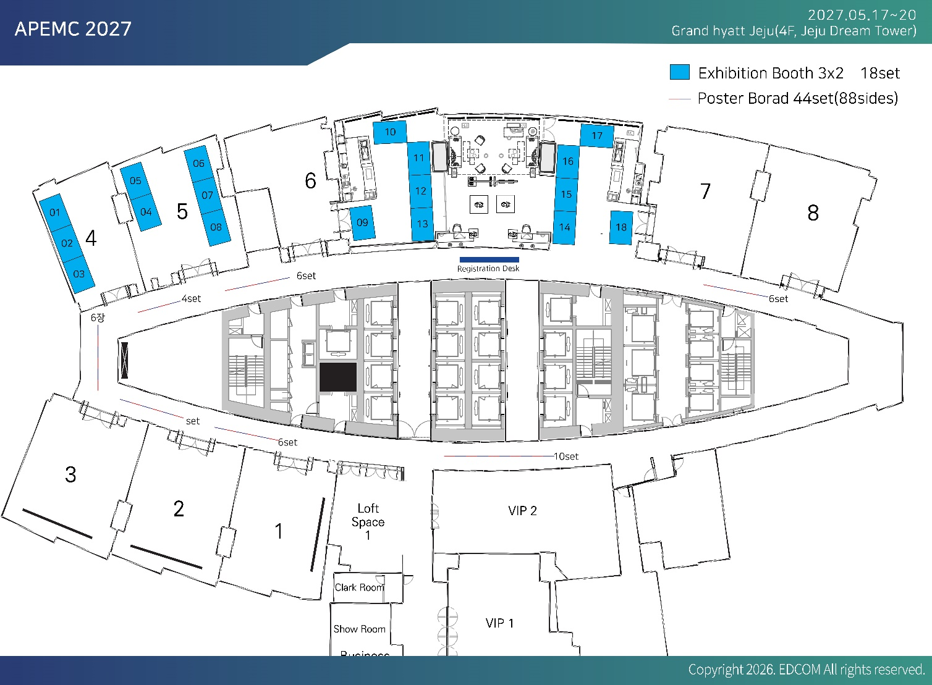

Exhibition & Sponsorship Application Form

- Company Information (Please complete the following information in English)
Company/Organization Name:
Address:
City: Zip: Country:
Contact Person: Position or Title:
Phone: Mobile:
E-mail: Website:
Describe company or products:
* Please attach your company logo and provide the website URL to be linked on the conference webpage.
* Detailed exhibition guidelines will be provided separately.

- Sponsorship Levels & Benefits (Please mark “X” in the appropriate box.)
Tier |  | Fee | Exhibit booth / Registration | Visibility Benefits
Diamond |  | USD 15,000 | 2 booths,  4 complimentary registrations | 1-page program book ad  web & on-site logo
Gold |  | USD 7,500 | 1 booth,  3 complimentary registrations | 1-page program book ad  web & on-site logo
Silver |  | USD 3,750 | 1 booth,  2 complimentary registration | 1-page program book ad  web & on-site logo
Bronze |  | USD 1,150 | No booth,  1 complimentary registration | 1-page program book ad  web & on-site logo
Exhibition |  | USD 1,500 | 1 booth, 1 exhibition registration | web & on-site logo

- Payment Method
Payment must be made by bank transfer only. Payments may be made in U.S. Dollars (USD)
Bank Information;
- Bank Name: Industrial Bank of Korea
- Bank Address:79, Eulji-ro, Jung-gu, Seoul, Republic of Korea (Phone: 82-2-712-0081)
- Account No: 208-017491-01-198 - SWIFT Code: IBKOKRSE
- Recipient: The Korean Institute of Electromagnetic Engineering and Science (KIEES)
* Cancellation policy : Before March 31, 2027 : 100% of full payment will be refunded.
From April 1, 2027 : Full payment will not be refunded.
Cancellation of exhibition must be made in written format to the secretariat via e-mail.
- Authorized Signature

Name Title Date
Please return this complete application with your payment confirmation to the APEMC 2027 Secretariat below :
Phone:+82-2-337-9666 Email: secretariat@apemc2027.org

